Published by | Editor

HEWI
Marketing + Innovation

HEWI Heinrich Wilke GmbH
P.O. box 1260
D-34442 Bad Arolsen
Phone: +49 5691 82-0
presse@hewi.de
www.hewi.com

Lisa Meyer-Floren
Phone: +49 5691 82-214
lmeyer-floren@hewi.de

Nicolo Martin
Phone: +49 5691 82-106
nmartin@hewi.de

Reprint free - specimen copy requested

System 900

Clever technology
System 900 impresses with clever assembly technology. The new type of corner connection makes the rail systems and shower handrails particularly easy to install. With the innovative push-lock principle, only three roses are required instead of the usual four fixing points. This makes the assembly significantly faster.
Well thought-through functions
The functions of System 900 are coordinated to the highly different standards of the respective area of use. Preconfigured products make subsequent addition of individual product functions unnecessary. The products have convincing varied technical refinements: For example, the System 900 hinged support rails are equipped with a maintenance-free brake. A defined stop prevents the hinged support rail from hitting the wall. The hinged support handles are designed in such a way to enable extreme stability: An additional stiffening increases the safety and provides reliable retention.
Hygienic design
The products are manufactured from few components, thereby resulting in an extremely small number of connection positions. The connection positions are manufactured extremely precisely by using laser technology. They are characterised by their minimum gap dimensions. Concealed fixing also contributes to the hygienic design. The result is surface finishes which are particularly easy to clean.
Optionally, the wall brackets of the hinged support rails and shower seats, as well as the fixing roses of the grab bars and rail systems, can be fitted with a sealing strip. This reliably seals between the fixing element to the wall - even with a tile offset or in case of uneven joints.

New surface finish provides room character
Decades of experience, constant ongoing development, an understanding of design and materials and a focus on the essentials make HEWI an expert for barrier-free sanitary rooms. Driven by the idea of making something what was previously good even better, HEWI is constantly working on new concepts that help to make life easier for people.
System 900 is the answer to the complex requirements of barrier-free, accessible bathrooms. The products are well thought-through, even down to the smallest detail – they have convincing functionality, lasting quality, clever installation technology and a hygienic design. System 900 combines puristic design with a high degree of functionality and a unique product depth. System 900 enables comfort and convenience to be be designed. HEWI believes good design should also involve providing options. Due to the large variety of materials, System 900 enables design options - whether regarding the standard patient bathroom of a hospital, in the comfort ward of a private clinic or in the exclusive senior citizens' residence. Even in hotels, System 900 also fulfils excellent comfort and aesthetics standards.
System 900 in a matt look enables HEWI to provide a new, exciting source of inspiration. System 900 is available with a stainless steel or chrome surface finish and with a deep mat surface finish in white, grey or black. Authentic, honest materials and the timeless and expressive product design provides character for rooms.

Design: NOA
Awards: German Innovation Award 2019
ICONIC Award Innovative Architecture 2018 winner
German Design Award Winner
iF GOLD Award 2019

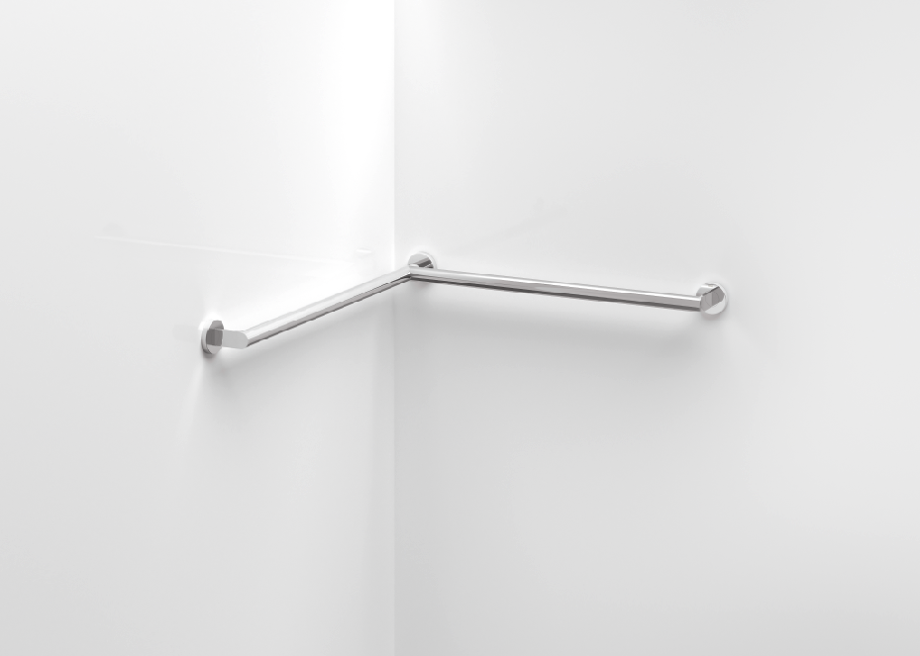
Innovative push-lock principle

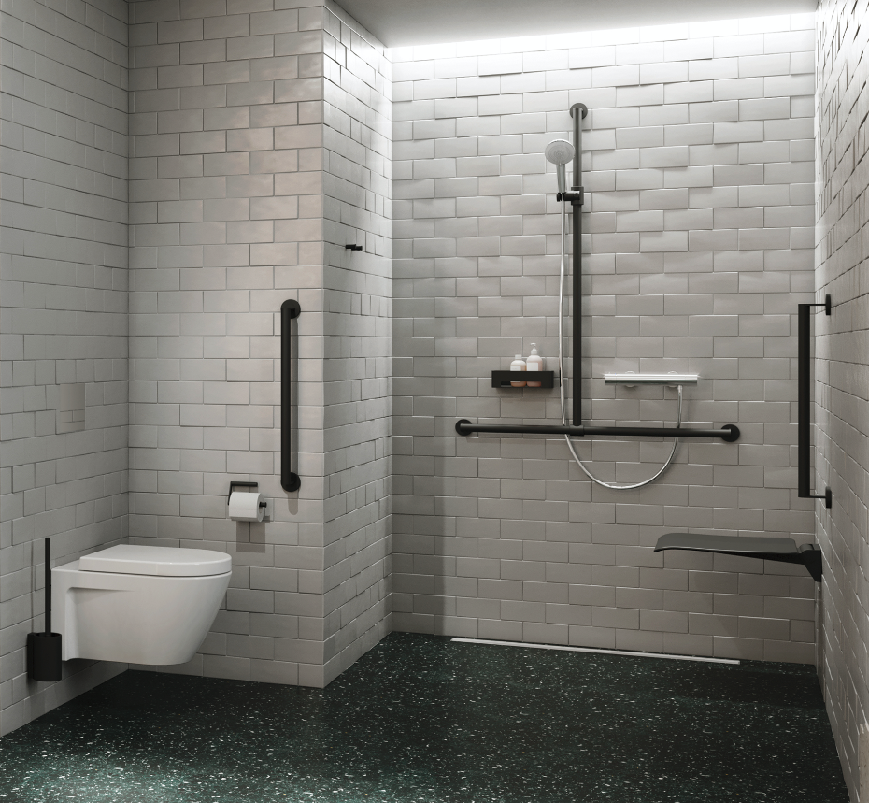

System 900 | New surface finishes

