Publisher | Editors

HEWI
Marketing + Innovation

HEWI Heinrich Wilke GmbH
PO Box 1260
D-34442 Bad Arolsen
Phone: +49 5691 82-0
presse@hewi.de
www.hewi.com

Clara Brenneker
Phone: +49 5691 82-214
cbrenneker@hewi.de

Nicolo Martin
Phone: +49 5691 82-106
nmartin@hewi.de

Reprint free of charge - copy requested

Smart in the bathroom - sensor-controlled products from HEWI

Hygiene and sustainability are becoming increasingly important in people's minds. With the beginning of the Covid-19 pandemic and the Fridays for Future movement, the demand for hygiene and sustainability has increased. Particularly in public and high-traffic areas, the demand for implementation is high. With sensor-controlled products, HEWI offers functional and design-oriented solutions that make the bathroom experience even smarter and create added hygiene and sustainability.

Hygiene and sustainability - sensor-controlled fittings

HEWI fittings are well thought-out down to the smallest detail and are characterised by a high level of operating convenience, easy cleaning, hygienic design, safe use and ease of maintenance.The HEWI Sensoric taps enable a new way of washing hands completely without touching. A hand movement is sufficient to start the water flow and a preset time interval to let it end automatically. In this way, there is no need for touching and the transfer of germs is stopped. Also the settling of germs inside is prevented thanks to the integrated hygienic flushing. The time of the flush can be set via an app. This saves water resources and increases hygiene in sanitary rooms. In addition, the cleaning effort for the fittings is reduced. The sensor-controlled fittings are available with matt and glossy surfaces.

Conserving resources - Sensor-controlled dispenser systems

HEWI offers a wide range of sensor-controlled dispenser systems that meet the highest demands in terms of design and functionality. In addition to sensor-controlled soap and disinfectant dispensers, the range also includes sensor-controlled paper towel dispensers. They can all be perfectly integrated into any room concept thanks to their different surfaces. There is a choice of polyamide, antimicrobial polyamide, powder-coated models in black, grey and white and stainless steel versions.They all reduce the risk of infection through their non-contact use and ensure greater hygiene in sanitary rooms. The option of individually setting the amount of soap and disinfectant allows for resource-saving and sustainable action.

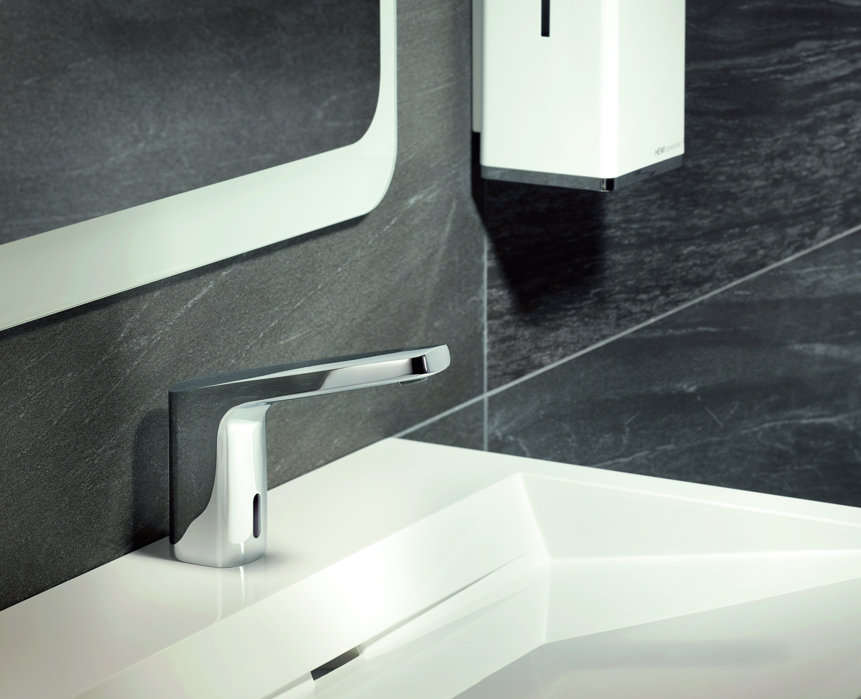
Sensor-controlled HEWI fitting

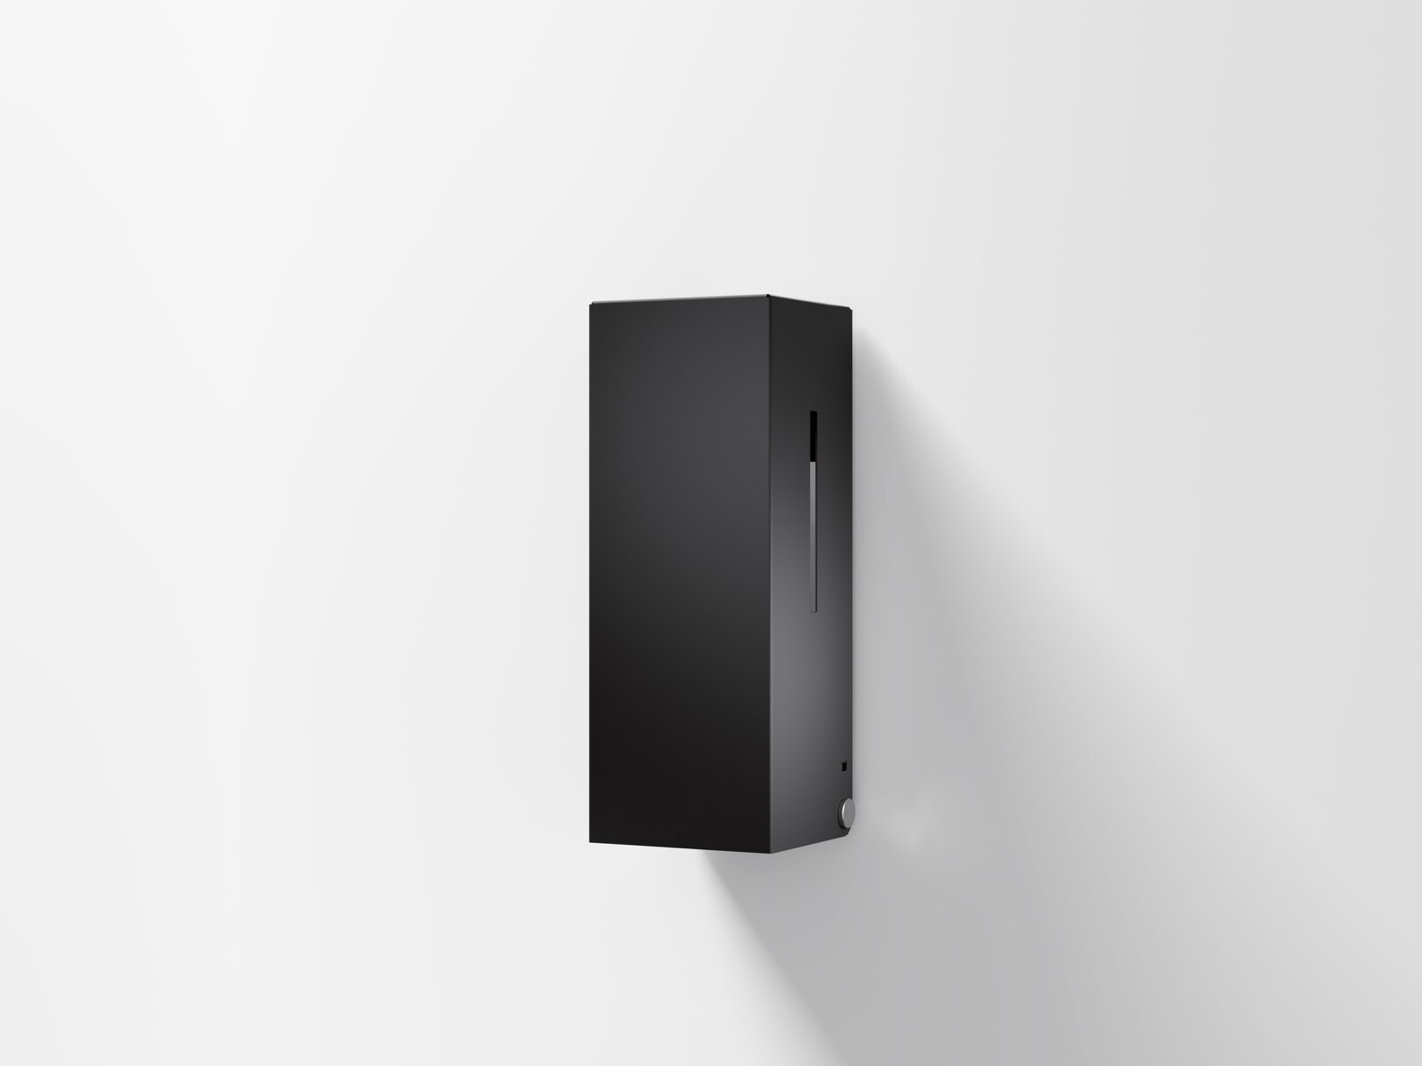
Touch-free disinfection dispensers enable hygienic hand disinfection

