Publisher | Editors

HEWI
Marketing + Innovation

HEWI Heinrich Wilke GmbH
PO Box 1260
D-34442 Bad Arolsen
Phone: +49 5691 82-0
presse@hewi.de
www.hewi.com

Reprint free of charge - copy requested

LifeSystem
The professional system for care
LifeSystem puts people at the centre. It can be used intuitively, regardless of physical requirements. Adaptable, expandable and flexibly usable products promote the independence and mobility of the user without neglecting the aesthetic design. Form and function form a unity in LifeSystem. The sanitary system offers comfort and safety in equal measure. Functionality, flexibility, easy care and robustness support care staff in their daily work and thus make LifeSystem a professional system for care. The modularity of the system enables individual solutions.
This means that the products can be flexibly adapted to the respective body dimensions of the user: the shower seat, for example, is height-adjustable and the projection of the folding support handle can also be changed. The upgradeability enables flexible adaptation to the user's needs - for example, the shower seat can be supplemented with individually folding armrests.
The products were developed according to ergonomic and kinaesthetic aspects in order to optimally promote the mobility and independence of the users. They help to compensate for physical limitations. Well thought-out product details offer both comfortable and safe use. Together, the products result in an intelligent system that supports the user and also the caregiver.

Design: NOA Product Design, Aachen
Awards: red dot award: product design 2003

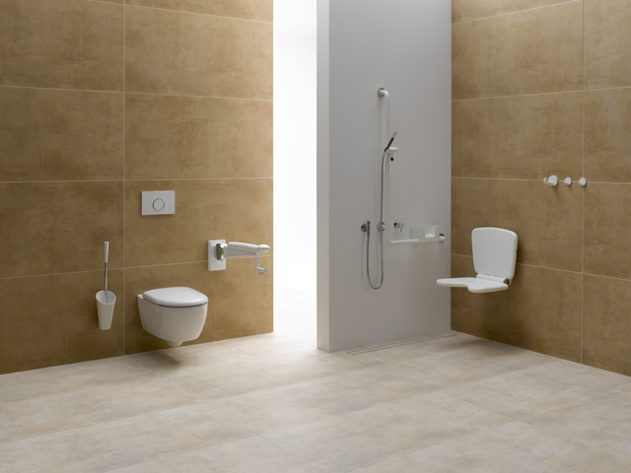
LifeSystem

For more information, please contact:

HEWI Heinrich Wilke GmbH
PO Box 12 60
D-34442 Bad Arolsen
Phone +49 5691 82-0
E-mail: presse@hewi.de
Internet: www.hewi.com

