Subscribe to DeepL Pro to edit this document.
Visit www.DeepL.com/profor more information.
Publisher | Editors

HEWI
Marketing + Innovation

HEWI Heinrich Wilke GmbH
PO Box 1260
D-34442 Bad Arolsen
Phone: +49 5691 82-0
presse@hewi.de
www.hewi.com

Reprint free of charge - copy requested

EPD certification
System 111
Environmental Product Declarations (EPD/Enviromental Product Declaration) form the basis for assessing the sustainability of a building. In Germany, the life cycle assessment of buildings is drawn up according to the DGNB certification system. For this purpose, the internationally recognised EPD certifications according to ISO 14025 and EN 150804 form the assessment basis at product level.
System 111 from HEWI was selected by the Fachverband Schloss- und Beschlagindustrie e.V. as a model solution for polyamide fittings. The Environmental Product Declaration was prepared by the Institut für Bauen und Umwelt e.V. as an independent expert.
The EPD summarises the life cycle assessment of a product. For this purpose, the effects on the environment are analysed from the production to the disposal of the product. For example, the origin of the raw materials is taken into account as well as the manufacturing process and the energy sources used for this, the product's service life, transport routes and the recyclability of the product.

Design: HEWI
Awards: iF product design award 1982
universal design award 2007
Design Plus 2007

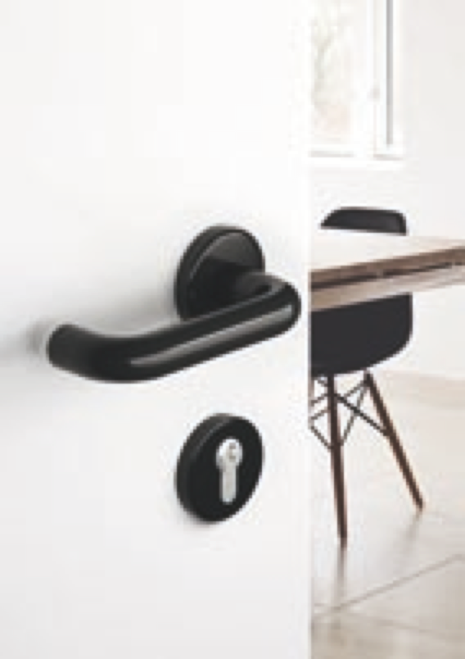
System 111

For more information, please contact:

HEWI Heinrich Wilke GmbH
PO Box 12 60
D-34442 Bad Arolsen
Phone +49 5691 82-0
E-mail: presse@hewi.de
Internet: www.hewi.com

