Publisher | Editors

HEWI
Marketing

HEWI Heinrich Wilke GmbH
PO Box 1260
D-34442 Bad Arolsen
Phone: +49 5691 82-0
presse@hewi.de
www.hewi.com

Reprint free of charge - copy requested

Edition matt
New surface
Matt surfaces set sensual accents. They can underline the style direction or create exciting counterpoints in combination with high-glosssurfaces.
At HEWI, the choice of surface is an independent dimension of the product design. With the matt edition, HEWI offers a unique surface that appeals to the senses and at the same time creates space for individuality.
The lever handle models 250 and 162 emphasise the characteristic look of the matt edition. Personal design objects can be created in combination with bicolor or mini. Matching furniture fittings, coat hangers and hooks in a matt finish enable a consistent design. Whether on the door or the furniture - the Edition matt sets extraordinary accents with a very special feel.
The velvety finish of the Edition matt is achieved by a special finishing process in which the polyamide products are processed by hand. This is how unique design objects made in Germany are created.

Design: HEWI, Bad Arolsen
Giancarlo Raddi, Florence

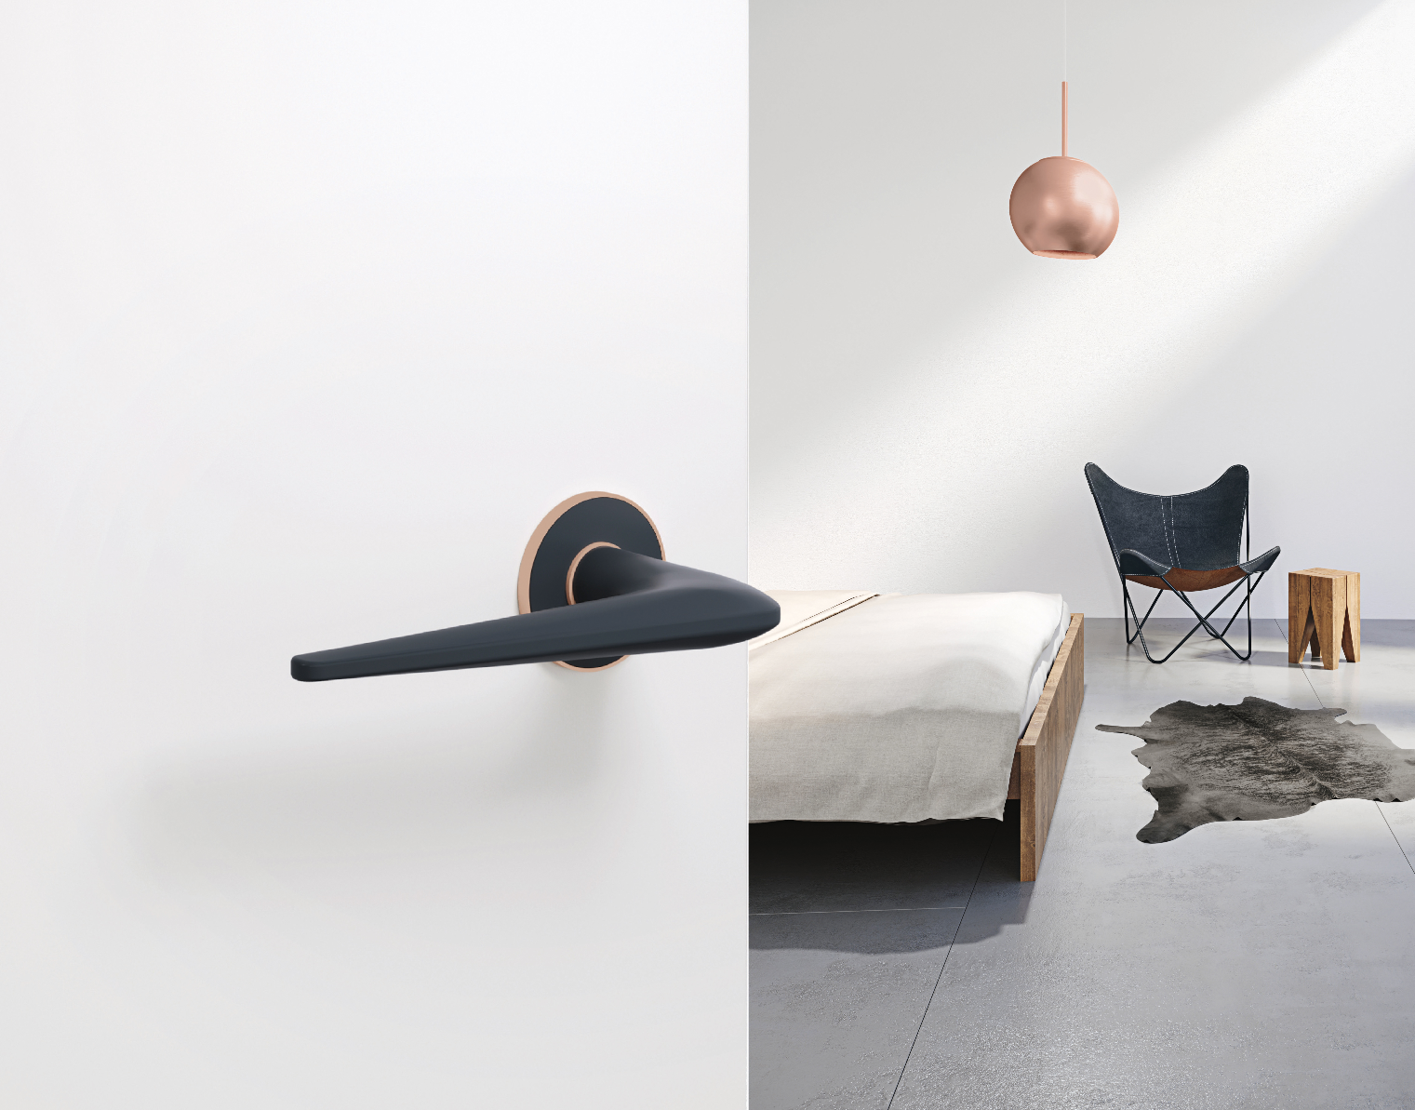

With the matt edition, HEWI offers a unique surface innovation.

For more information, please contact:

HEWI Heinrich Wilke GmbH
PO Box 12 60
D-34442 Bad Arolsen
Phone +49 5691 82-0
Email: presse@hewi.de
Internet: www.hewi.com

