Publisher | Editors

HEWI
Marketing + Innovation

HEWI Heinrich Wilke GmbH
PO Box 1260
D-34442 Bad Arolsen
Phone: +49 5691 82-0
presse@hewi.de
www.hewi.com

Reprint free of charge - copy requested

Dementia washbasin
Guidance
More than 44 million people worldwide suffer from dementia. In Germany, there are currently around 1.5 million. Every year, the number of patients increases by around 300,000. Dementia poses particular problems for those affected and their environment. The orientation disorders that intensify in the course of dementia severely restrict the independence of people suffering from dementia and are often one of the reasons for moving into a care facility. It is very difficult for people suffering from dementia to open up a new living environment due to their cognitive impairments. They are dependent on clear structures that offer them spatial and situational orientation and maintain their independence.
Color and function
HEWI has developed a washbasin especially for dementia patients. The washbasin has integrated handles that can be used for pulling up and holding on. The functions of the washbasin are signalled via permanently attached coloured markings. Both the integrated grab rails and the washbasin are outlined in colour and thus highlighted. This makes it easier for people suffering from dementia to perceive the washbasin in the room and to understand how to use it. This promotes orientation and thus independence.
Qualitative studies on the colour perception of people suffering from dementia show that the colour red is most likely to be perceived. For this reason, the coloured markings of the washstand were designed in red.
Red is also the colour that is most easily registered in the case of declining vision in old age or inoperable eye diseases, such as macular degeneration. Thus, the dementia washbasin is also suitable for people with age-related visual impairments, provides orientation and promotes independence.

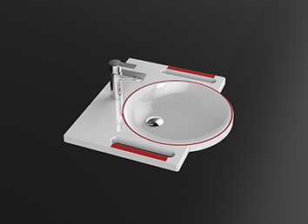
Dementia washbasin

For more information, please contact:

HEWI Heinrich Wilke GmbH
PO Box 12 60
D-34442 Bad Arolsen
Phone +49 5691 82-0
Email: presse@hewi.de
Internet: www.hewi.com

