Publisher | Editors

HEWI
Marketing + Innovation

HEWI Heinrich Wilke GmbH
PO Box 1260
D-34442 Bad Arolsen
Phone: +49 5691 82-0
presse@hewi.de
www.hewi.com

Nicolo Martin
Phone: +49 5691 82-106
nmartin@hewi.de

Reprint free of charge - copy requested

Architects' Darling Award 2020
Architects award HEWI two prizes
The Architects' Darling Awards were presented by Heinze for the tenth time. As the promoter and organiser of the Architects' Darling Awards, the construction network Heinze does not select the winners itself, but presents the trophies on behalf of the winners. The winners are determined in one of the largest industry surveys in the construction industry.

HEWI awarded in two categories
Around 1,900 architects took part in the survey and determined the favourites of the building industry in 2020. HEWI was able to receive an award in no less than two categories: HEWI was named the winner in the accessibility category - so that HEWI was able to accept the golden phoenix. HEWI also received the Architects' Darling Award in silver in the fittings category.

Barrier-free sanitary solutions in all areas of life
At HEWI, accessibility is not a feature of a specific series. Accessible product solutions are integrated into all HEWI systems so that accessibility becomes a matter of course. With new design lines and surfaces, HEWI has shown in recent years that accessibility can be functional and aesthetic.

HEWI has developed a surface alternative for the barrier-free classic Series 477/801. The sanitary series in the matt edition makes a design statement in white and grey tones. The elegant matt surface sets accents and convinces with a very special feel.

System 900 is not only the most comprehensive design line in the accessible sanitary fittings segment. With its surfaces in stainless steel, chrome and powder coatings in black, white and grey tones, the high-quality sanitary series offers design options for architects.

With the modular washbasin concept, HEWI was able to present an innovative and unique washbasin system in barrier-free bathroom fittings. The washbasins can be extended with useful elements using the modular system - as required by the individual needs of the user.

Door handles set accents
With mini, matt and bicolour, HEWI has designed striking and timeless variants for the design icon System 111, which offer architects and planners creative design options on the door.

Two further lever handles from HEWI set new accents:
- The mitre cut is a distinctive design feature, which gives System 162 a noble appearance, especially in the matt edition.
- The design of the 270 series lever handle by Hadi Teherani has been reduced to the essentials and offers minimalism in its purest form with matt polished stainless steel and the mini rose.

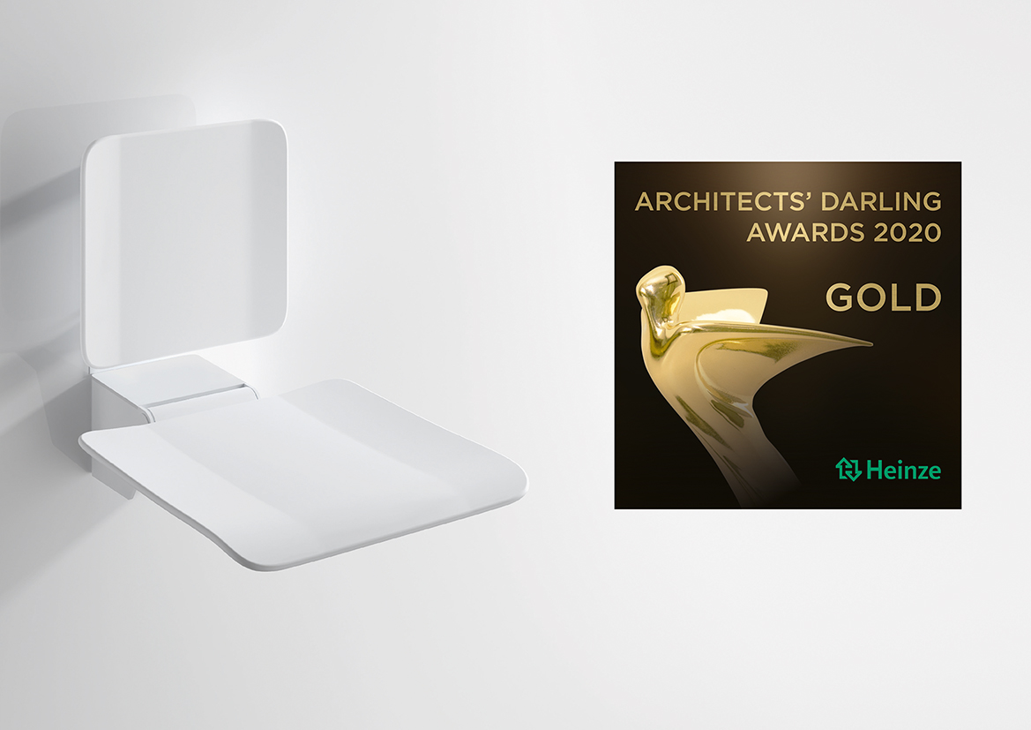

Architects' Darling Award in the Accessibility category for HEWI

