Publisher | Editors

HEWI
Marketing + Innovation

HEWI Heinrich Wilke GmbH
PO Box 1260
D-34442 Bad Arolsen
Phone: +49 5691 82-0
presse@hewi.de
www.hewi.com

Clara Brenneker
Phone: +49 5691 82-214
cbrenneker@hewi.de

Nicolo Martin
Phone: +49 5691 82-106
nmartin@hewi.de

Reprint free of charge - copy requested

HEWI triple award
German Design Award 2020
The German Design Award discovers and presents unique design trends: a competition that advances the design-oriented economy. HEWI received three awards.
In the "Furniture" category, the new, child-friendly M 20 furniture was convincing.
The modular washbasin system, which can be adapted to the individual needs of its user, was also awarded the "Winner" in the "Bath and Wellness" category.
A "Special Mention" in the "Excellent Product Design" category was awarded for the new 270 hardware series, which HEWI designed together with Hadi Teherani.
The competition is organised by the German Design Council. This is one of the leading international centres of excellence for design. Initiated by the German Federal Council, it has been supporting companies in their brand and design development for 65 years and strengthens German design as an economic factor.

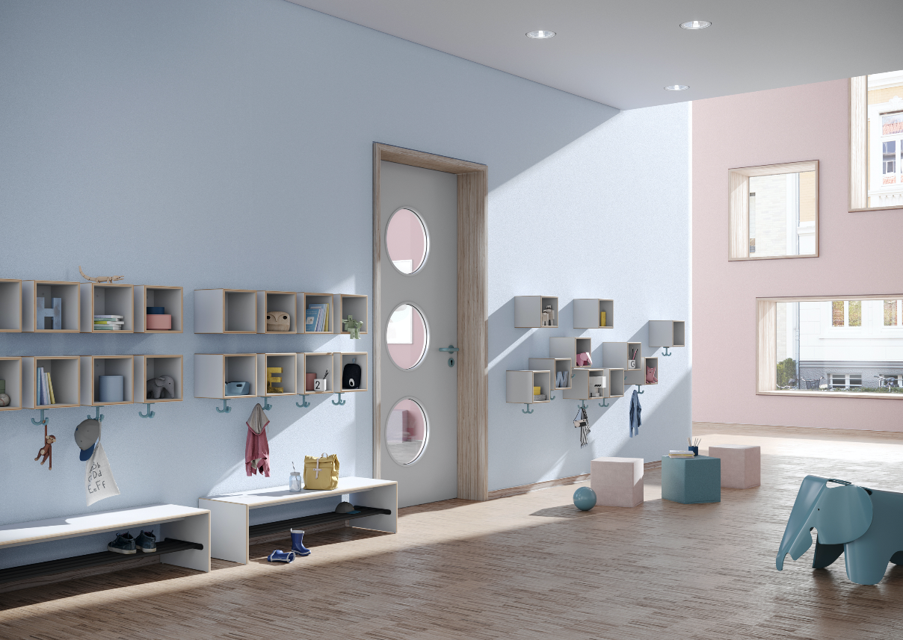
Kids Furniture M 20 | Winner in the Furniture category

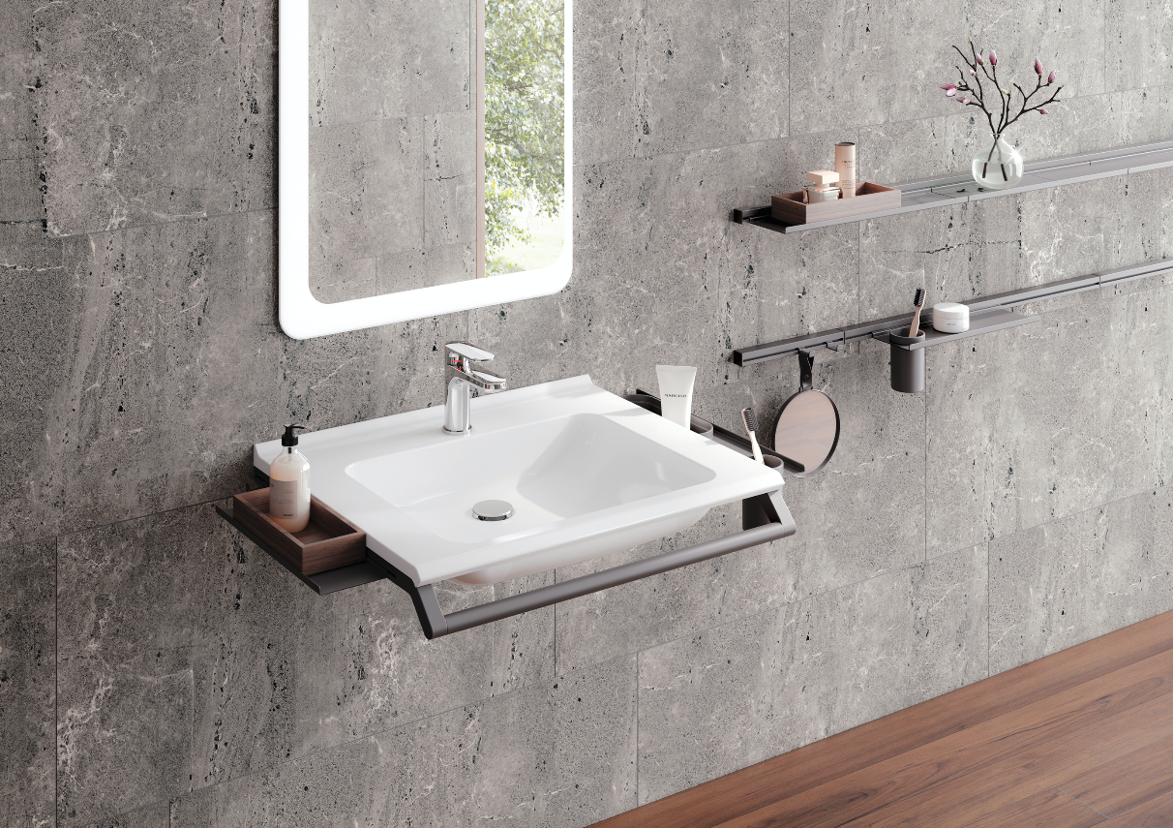

Modular washbasin system | Winner in the Bath and Wellness category

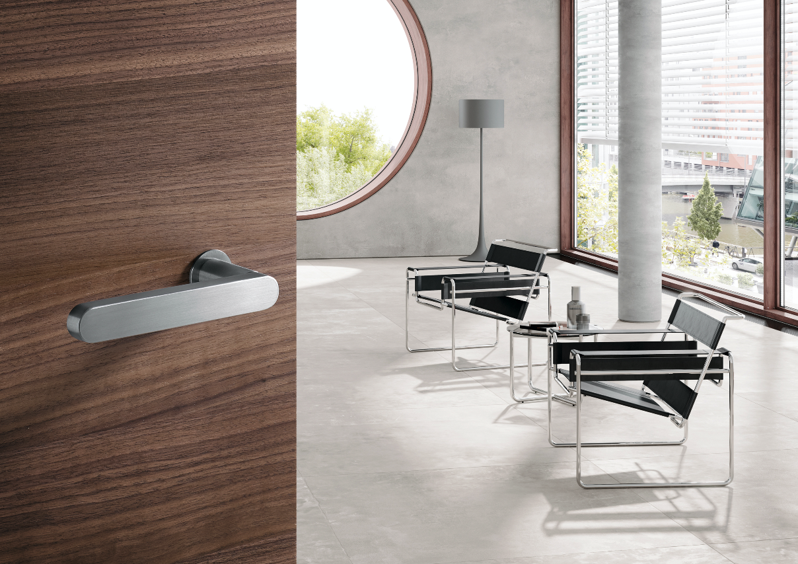

Series 270 | Special Mention in the category Excellent Product Design

