Publisher | Editors

HEWI
Marketing + Innovation

HEWI Heinrich Wilke GmbH
PO Box 1260
D-34442 Bad Arolsen
Phone: +49 5691 82-0
presse@hewi.de
www.hewi.com

Lisa Meyer-Floren
Phone: +49 5691 82-214
lmeyer-floren@hewi.de

Nicolo Martin
Phone: +49 5691 82-106
nmartin@hewi.de

Reprint free of charge - copy requested

HEWI awarded
Bathroom comfort for generations
The German Sanitation, Heating and Air Conditioning Association (ZVSHK) selected the winners of the "Bathroom Comfort for Generations" product competition for the fourth time at the world's leading trade fair for sanitation technology, the ISH in Frankfurt. An international jury of experts had previously selected five prize-worthy entries from the 46 nominated products at the trade fair. HEWI was awarded the coveted prize for its innovative sanitary system 900.
System 900 convinced the jury
System 900 is the answer to the complex requirements of barrier-free bathrooms. The products are well thought-out down to the smallest detail: they impress with functionality, durable quality, clever installation technology and hygienic design. System 900 meets the requirements of a wide variety of building types - whether in the regular patient bathroom of a hospital, in the comfort ward of a private clinic, in a nursing home or in an exclusive retirement home.
In the hotel or at home, System 900 also combines aesthetics with clever functions for more comfort in the bathroom. Material options allow freedom of design - System 900 is available with surfaces in stainless steel, chrome and with powder coating in various nuances. Deep matt white, light grey pearl mica, dark grey pearl mica and black offer design options.
"The modular design of System 900 allows for a wide range of combination options to optimally meet user needs and architecture. The clever installation technology is convincing: a new type of plug-in snap-in connection allows installation with fewer fastening points and the concealed fastening stands for hygiene and good design," said the jury, explaining its decision.

A success story
Despite an increase in the number of entries and higher requirements for innovative, individually usable concepts, HEWI is the only manufacturer to be among the winners of the competition for the fourth time in a row.

- 2013 | Awarded: Barrier-free washbasin family with integrated recessed grips
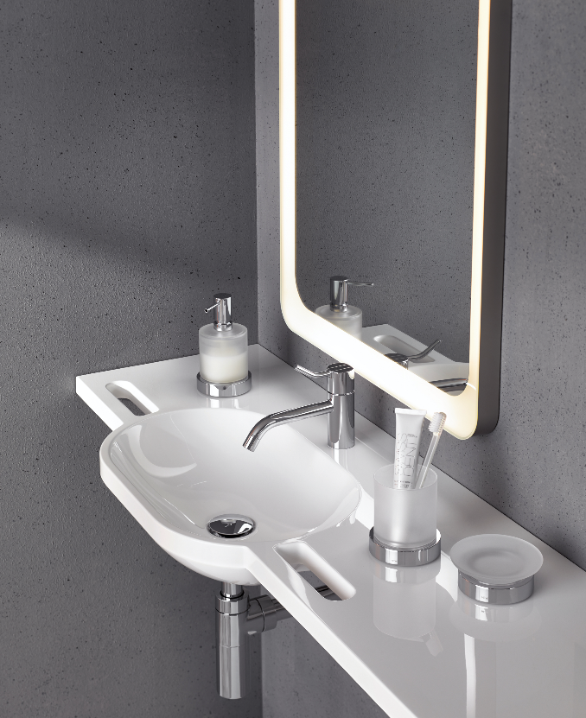
- 2015 | Award-winning: Seat concept for more safety in the shower
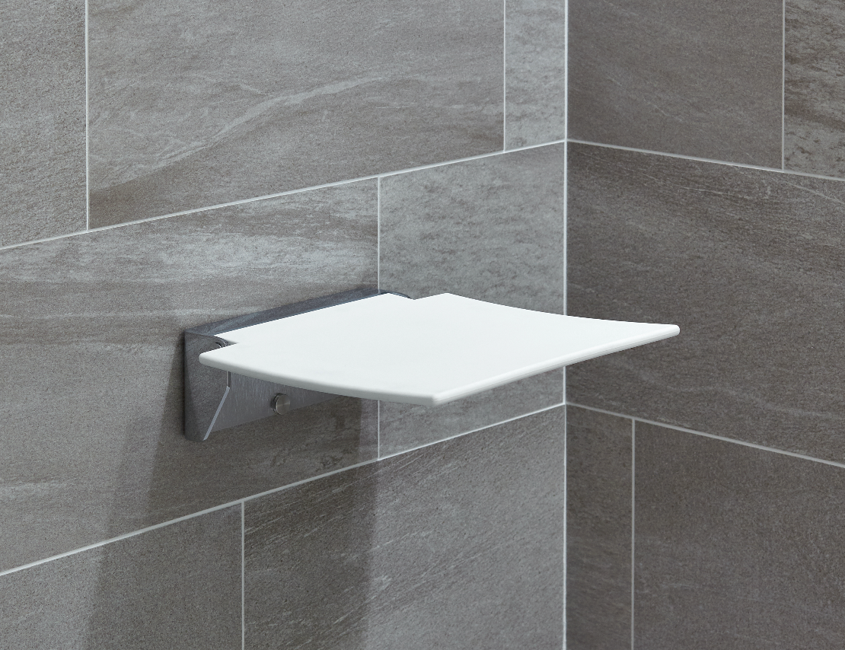
- 2017 | Award-winning: Individually height-adjustable washbasin and WC modules S 50
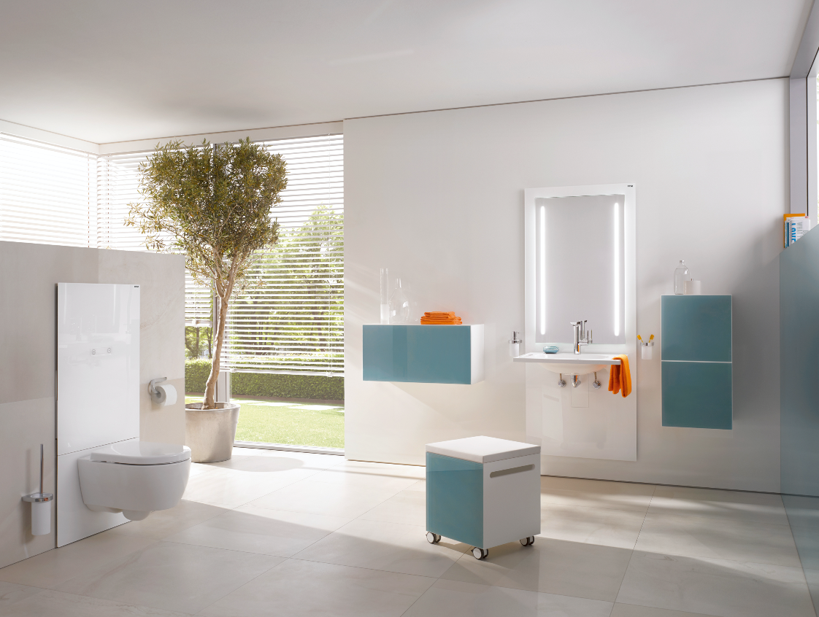
- 2019 | Award-winning: System 900 as the answer to the complex requirements of barrier-free bathrooms
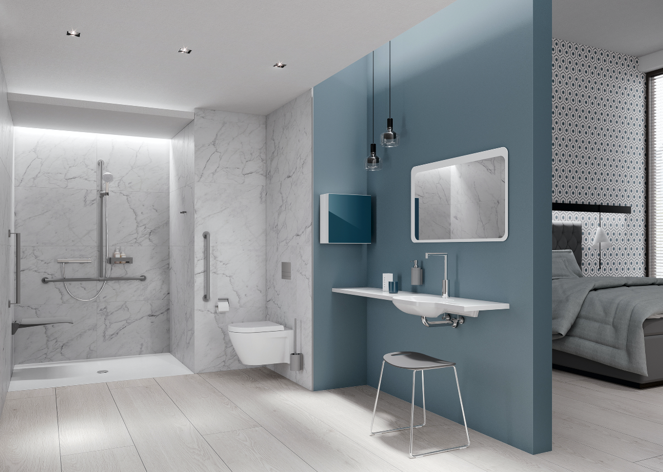

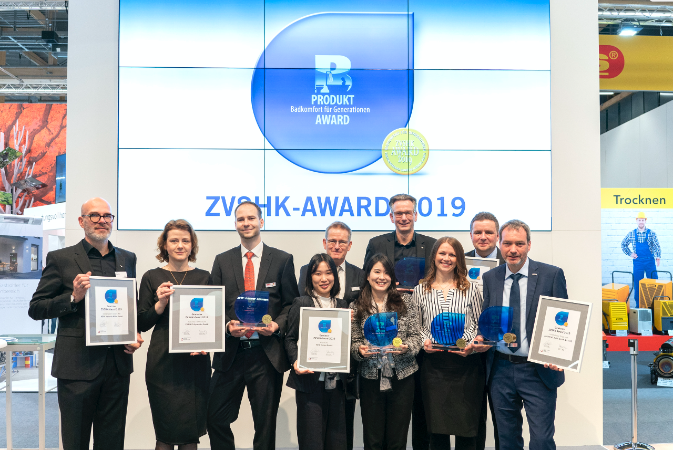
Matthias Fuchs (Division Manager Marketing + Innovation HEWI, 1st from left) and Thorsten Stute (Managing Director HEWI, 4th from right) accepted the award at the trade fair.

